**Lab #1: Measurements and Graphical Analysis**

**Purpose Statement:** Given “disks” of different radii, determine the relationship between the mass and radius of the disks through a graphical method. In using graphical methods, we will learn about linearization and the use of it to create a mathematical model.

**Procedure:**

1. Fold disks in half.
2. Measure the diameter.
3. Divide the diameter in half to find the radius.
4. Record data.
5. Unfold the disk.
6. Weight the disks on the scale and record data.
7. Fold a disk until it is one millimeter thick.
8. Divide one millimeter by the number of layers the disk now has to get the thickness.
9. Record data.

**Questions:**

1. What is the precision of the meterstick I used?

The precision of the meter stick is up to 0.1 millimeter.

1. Explain how you know this based on the data I provided.

We know this because the meter stick that was given to us goes to the millimeter. This means that when measuring something, it is usually measured in one below the exact level of precision.

**Mass and Radius Measurements**

|  | Radius (cm) | Mass (g) | Thickness (cm) |  | Radius Squared (cm2) |
| --- | --- | --- | --- | --- | --- |
| Disk 1 | 2.35 cm | 0.08g | 0.0015625 cm |  | 5.5225 |
| Disk 2 | 3.20 cm | 0.14g | 0.0015625 cm |  | 10.24 |
| Disk 3 | 4.10 cm | 0.23g | 0.0015625 cm |  | 16.81 |
| Disk 4 | 5.25 cm | 0.38g | 0.0015625 cm |  | 27.5625 |
| Disk 5 | 6.90 cm | 0.70g | 0.0015625 cm |  | 47.61 |

**Graph 1 (Mass vs Radius):** *y* = 0.018867*x*2 - 0.039*x* + 0.069478

Mass vs Radius

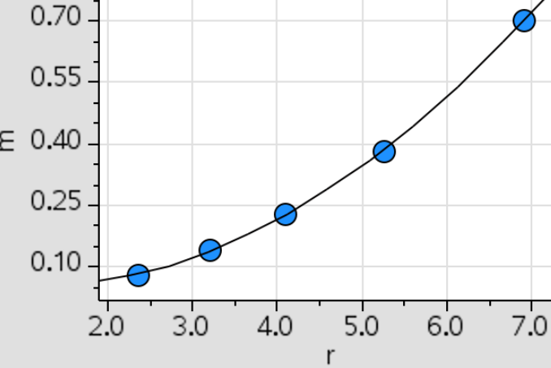

x-axis: radius (*r*)

y-axis: mass (*m*)

**Graph 2 (Mass vs. Radius Squared, linearized):** *y* = 0.014763*x* - 0.012136

Mass vs. Radius Squared

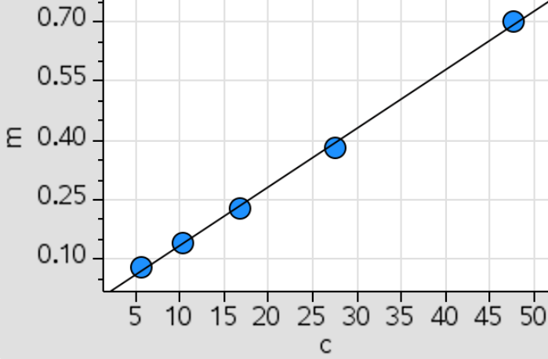

x-axis: radius squared (r2; also represented with *c* here)

y-axis: mass (*m*)

**Calculations:**

p = m/v → m = pv

v = π * r2 * h

constants

m = p * π * r2 * h → cm = (g/cm3) * π * cm2 * cm → cm = (g/cm3) * π * cm * cm2 → Equation 4: m = r2

**Analysis Questions:**

1. What is the independent variable in your y = mx +b formula?

The independent variable in the linearized graph is the radius squared (r2). This is because the mass of the disk depends on how large the disk is, which is measured with the radius.

1. What does the slope represent in your y = mx +b formula? Show dimensionally that indeed that is what your slope represents and that the formula is valid dimensionally.

The slope of the linearized graph represents the proportional relationship between the mass of the disks and the radius of the disks, squared. This is because when the original graph, which shows the relationship between mass and radius, is linearized, it is found that mass and the radius squared are proportional. This is derived below. This means that the units of the slope are g/cm2. When this is put into the linear equation, it can be derived that mass is equal to mass, which proves the relationship is valid dimensionally.

**Calculations:**

Density: p = m/v → m = pv Volume: v = π * r2 * h

constants

m = p * π * r2 * h → cm = (g/cm3) * π * cm2 * cm → cm = (g/cm3) * π * cm * cm2

Equation 4: m = r2

y = mx + b → g = g/cm2 * cm2 + g → g = g + g → g = g

1. Should the "b" in your y = mx + b formula be zero? Explain your answer.

The “b” of the linearized graph has to go through zero because theoretically, a circle with a radius of 0 will ultimately have a mass of 0. Experimentally this isn’t possible however because of data that is not precise.

1. Measure/estimate the "thickness" of your cylinders. Use that value to find the experimental density of your cylinders. Find a percent difference between your found density and the actual density. The actual material is aluminum.

Average Radius: (2.35 cm + 3.20 cm + 4.10 cm + 5.25 cm + 6.90 cm) / 5 = 4.36 cm

Average Mass: (0.08 g + 0.14 g + 0.23 g + 0.38 g + 0.70 g) / 5 = 0.306 g

Volume: 0.0015625 cm * (4.36 cm)2 * π = 0.093313 cm3

Density: 0.306 g / 0.093313 cm3 = 3.28 g/cm3

Percent Error: (|3.28 g/cm3 - 2.7 g/cm³| / |2.7 g/cm³|) * 100 = 21.48%

1. Errors. Make sure you explain why your number is bigger or smaller than (if positive or negative difference.)

Our number is smaller because our measured thickness is too thick. This is because the thickness of our materials that the disks are made of is really difficult to measure. This is because our material is aluminum foil and aluminum foil is very thin and hard to measure with a meter stick. We found that our disk measurements are too thin because if the thickness is increased, the volume that will be calculated is larger and when that volume is used to calculate the density, the larger volume value will decrease the final density value if all other variables stay constant. This is why our experimental value is larger than the theoretical value.

**Synthesis Questions:**

1. In this experiment, if we had used disks with a greater thickness, would the slope of your best fit line have been different? Would your experimental value for density be the same? Explain.

The slope of the line of best fit would’ve probably been more aligned with the experimental values. This means that the experimental value for density would be closer to the theoretical value because the chance of error while measuring the thickness of the disks would be less.

1. How would your graph of m versus r2 be different if you had used disks of the same thickness, but made out of steel? Draw a second line on your m versus r2 plot that represents disks made of steel.

The slope for the linearized graph would’ve been steeper because steel has a larger density than aluminum. This means that as the radius of the disks increase, the mass would increase at a faster rate, as the disks would be heavier because of the larger density.

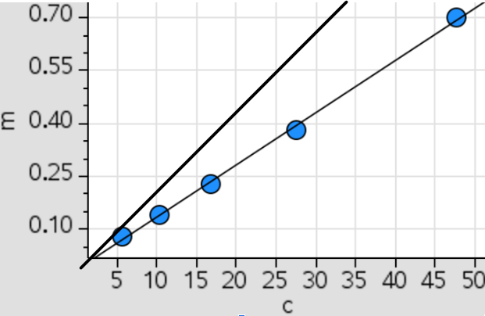

1. Another group of students has acquired data for the exact same experiment; however, their disks are made of an unknown material that they are trying to determine. The group's m versus r2 data produced a line of best fit with slope equal to 122 kg/m2. Each disk they measured had the same 0.5 cm thickness. Calculate the density of the unknown material and use the table below to help determine what material their disks are made of.

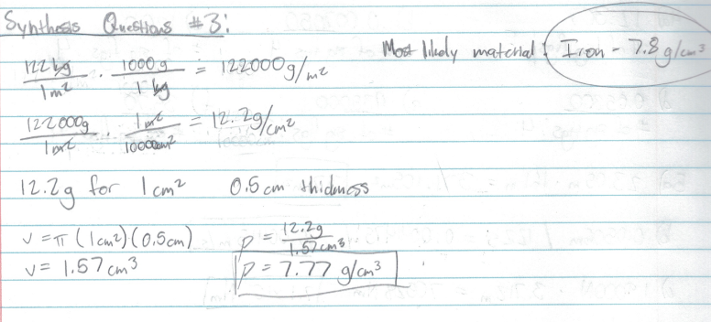

**Multiple Choice Questions:**

1. You perform the same experiment, but this time you plot a linear relationship between mass and the circumference of the disks rather than the radius. What is the slope of the linear plot?

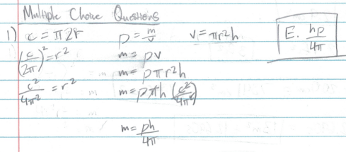

1. Consider an experiment in which a student measures the mass and diameter of 10 different-sized spheres, all made of the same material of uniform density ρ. For this student to create a linear graph relating the mass of the sphere to its radius r, the student would need to plot mass m versus which quantity:

